[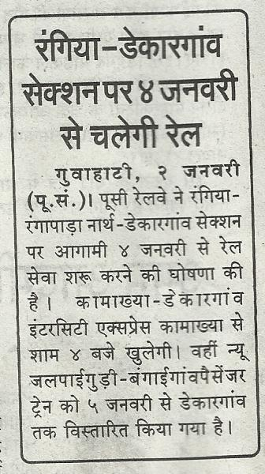](http://indiarailinfo.com/station/blog/dekargaon-dgtb/8015)