Diesel Locomotives Applications For Class WDG-4 & WDG-4D
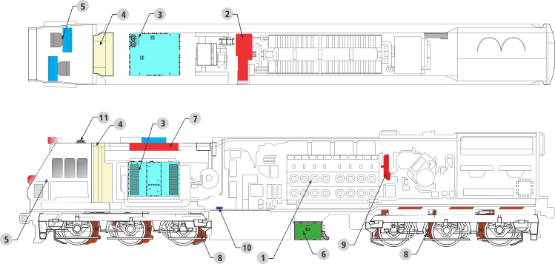
- Engine (MFI, EFI or CRDI)
- Alternator (AC)
- Traction Converter (IGBT Based)
- Control Panel (Microprocessor Control with electricals)
- Driver Console (with TFT LCD displays)
- Hotel Load Converter (HEP)
- Dynamic Brake Resistor (DBR Grids)
- Traction Motors (AC)
- Electronic Governor / CRDI (Retrofit)
- Fuel Level Sensors (Ultrasonic type)
- Locomotive Remote Monitoring (LRMS)
Medha offers range of traction and propulsion system solutions for Diesel-Electric Locomotives. The requirement can be for manufacture of new locomotives, renewed life for old locomotives or for technological upgrades.
Implementation of complete traction chain may include engine(s), alternator, rectifier, traction converter(s), traction motors, advanced controls, driver console, electricals and other sub-assemblies.
Solutions are available for different track gauges and locomotive ratings.

Advantages
- Increased availability
- Increased haulage capacity (improved adhesion)
- Increased lease rentals per locomotive
- Increased horse power rating of locomotives
- Lower life cycle costs
- Reduced lube oil consumption (upto 70%)
- Advanced safety features
- Reduced maintenance (upto 50%)
- Fault diagnostics and remote monitoring over internet

3 MW Diesel Locomotives:
- 4000 HP to 4500 HP (wide gauge), GT46MAC, EMD engine, 3 MW IGBT converter, individual motor control, locomotive controls, 500 kVA HEP converter, distributed power.
- http://www.medhaindia.com/

